***SCM PRACTICAL REPORT***

**Name:** Harshada.P.Madane

**Class:** SY BBA-IB

**Roll No.** 14653

**INDUSTRY VISIT REPORT**

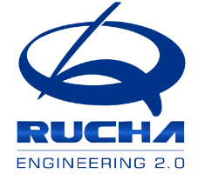

* **COMPANY PROFILE:**

RUCHA Group are engaged in designing, developing & mass manufacturing of engineering-intensive industrial products for automotive and other applications.

Their tagline signifies new & refined approach in everything they do: especially, revisiting engineering basics & surpassing normality.

Incepted in the year 1987, Rucha group over the years has transformed into a global tier-1 automotive component manufacturer and supplier of press parts, structural elements, transmission systems, exhaust systems, engine related assemblies and plastic moulded parts and components to passenger car, commercial vehicle, two-wheeler, and three-wheeler OEMs worldwide. With 10 world-class manufacturing facilities and 1 R&D centre in spread across 5 locations in India, Rucha group is on an above exceptional growth trajectory clocking a sale of above 100 million USD in 2017-18. The company is one of the leading car component suppliers and amongst the top 3-wheeler automotive component supplier in India. Rucha offers exceptional engineering edge and competitive value that in turn provides competitive edge in the market.

* **Vision and Mission:**

A globally preferred supplier based on our engineering edge.

A benchmark company.

Targeted growth of 25% YoY.

Balanced growth

Moving up the technology ladder

Value creation

Being “Partner of Choice” to all stakeholders.

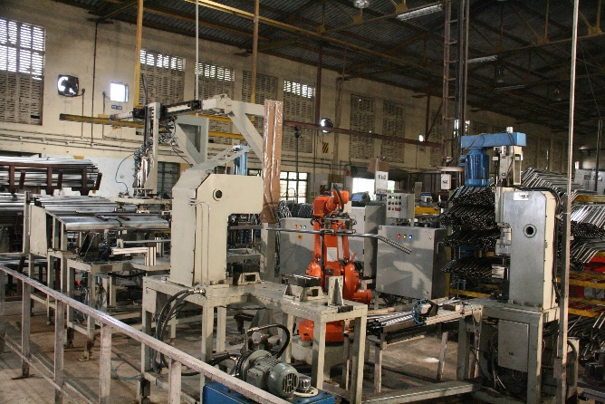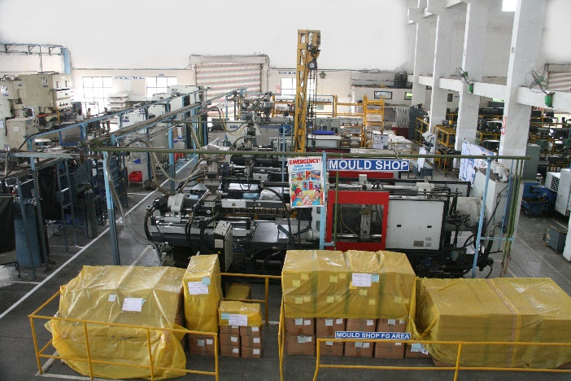

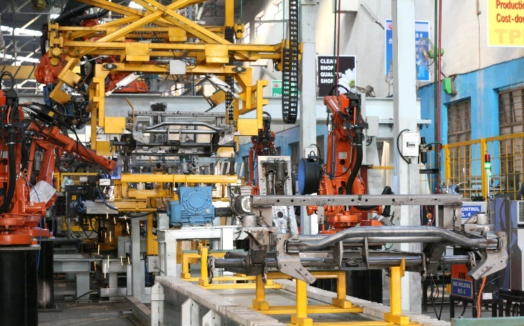

* **Supply chain aspects:**

The company has to be depended on the two types of supply chain i.e., internal mobility and external mobility. And I observed that in that both ‘Rucha engineering’ does a good job. Incase of internal mobility company uses various MHE such as Cranes and hoists to transport the steel and metal foils to the storage area. Similarly for the transport of the sheet’s trolleys are used by the employees so the movement of goods from one step to another will be done perfectly in swift way. Once the production is done the final product is stored in the one location in the palletized process so that during transport it will be easy to carry. The organization used mostly plastic pallets, this may be due to its reusable feature and cheap cost.

Now, if we do discuss about their external mobility (i.e. their movements of goods once production activity is done) they use forklifts (diesel operated mostly) to transport those pallets on the trucks. This companies use road mode of transport to transport the goods to their destined location.

* **Manufacturing Layout of company:**

Rucha engineering used ‘Product layout’ i.e., also called as line layout. In this type of manufacturing the goods move from step to other in a line manner. An alloy sheet moving from the raw material moves from the step to step manner and in last gets move towards the packing stage and is properly checked and packed by the employee.

* **Scrap Management:**

When we talk about the manufacturing the question of scrap management does always arise in the mind of the entrepreneur. So this problem has been tackled by this organization by taking various perfectly condensed steps. This organization had first of all created a different space for the scrap and this is essential as if scrap will be near manufacturing area it may lead to delays in transport or sometimes fatal accidents can be occurred.

Then on this selected place the organization had distributed it in the different section i.e., metal and plastic. This may be to avoid confusion and save time during management time (As plastic needs to be either reused or disposed, but steel can be used in the manufacturing again as steel scrap has various uses in manufacturing.)

* **Products:**

REPL for long has stressed the quality of products and services that it provides to its customers and stakeholders. The focus and dedication provided to this arena have led REPL to evolve into a centre of manufacturing excellence over generations of effort and dedicated hard work. The awards, the accolades and the trust of our customers in our products and people are living testimonials to our capability and experience in developing and executing excellent manufacturing systems.

The products are frames/ structural, transmission, exhaust systems, engine related, plastic moulded parts, skin panels etc.

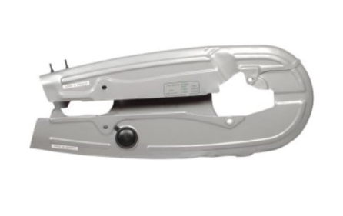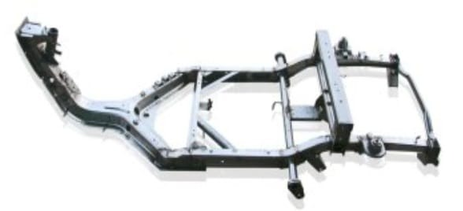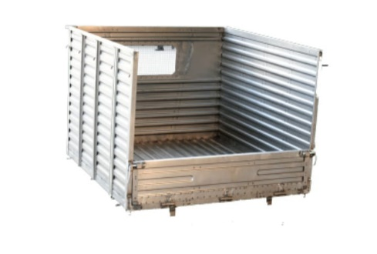

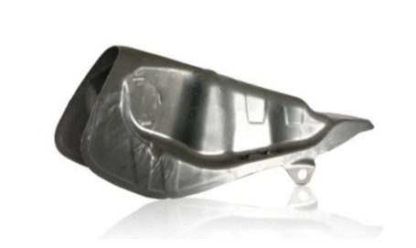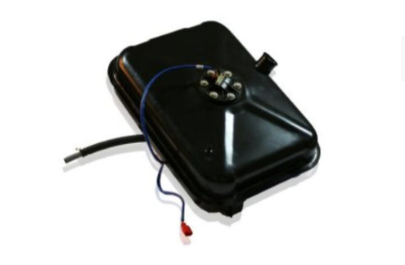

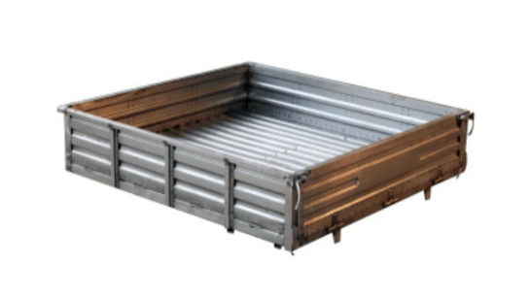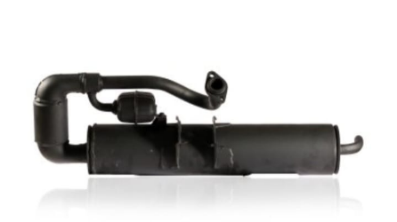

* **Observation:**

Rucha Engineering Pvt Ltd have several plants over there, among those we visited the plant 7. We saw the manufacturing process of the products they manufactured and also about products and machines. They manufacture spare parts of the car Volkswagen. The organization uses scheduling type of method while production. They specialize in the production of plastic components for the automotive and industrial sectors. Also I observed that the employee was given a certain time to complete task within given time and also there is a master sample board displayed in which information of customer is displayed, production plan is displayed on white board etc. There were also safety sensor included for the employees. There’s a scrap yard at the backside.

**GREEN SUPPLY CHAIN REPORT**

1. **Nestlé**

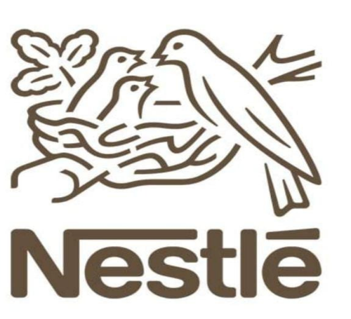

* **COMPANY PROFILE:**
* 2019 revenue: $93 billion
* Number of employees: 352,000
* Headquarters: Switzerland

Nestlé is the world’s largest food and beverage company. It is present in 187 countries around the world, and its 291,000 employees are committed to Nestlé’s purpose of unlocking the power of food to enhance quality for everyone, today and for generations to come. Nestle SA (Nestle) is a manufacturer and marketer of food products and beverages. The company's product portfolio comprises baby foods, bottled water, cereals, chocolates and confectionery, coffee, culinary products, chilled and frozen foods, dairy products, nutritional products, ice cream, and pet products.

* **CONTRIBUTION TOWARDS GREEN SUPPLY CHAIN:**

This Swiss food and beverage multinational is adept at enabling sustainability victories by driving partnerships. Either with their suppliers, with environmental organizations, or with other corporations, their Creating Shared Value strategy is their framework that underscores their commitment to sustainability collaboration. Examples of this work include their Caring for Water initiative that outlines a set of tools and information required to enable water conservation throughout their supply chain, as well as their collaboration with the World Business Council for Sustainable Development to help create agriculture-sector guidance for responding to the risks of climate change. Nestlé is also a founding member of the Sustainable Agriculture Initiative, a platform for sharing knowledge and information with the goal of implementing sustainable agricultural practices through the food supply chain. The platform counts more than 60 organizations as members. In addition, they are actively involved in the UN Sustainable Development Goals and disclose their involvement and progress against all 17 goals.

**Sustainability resume:**

* Nestlé’s ambition is to strive for zero environmental impact in their operations by 2030
* The company has been a listed member of the FTSE4Good index since 2011
* Nestlé is committed to reducing absolute scope 1, 2 and 3 GHG emissions 20% by 2025 and 50% by 2030 from a 2018 base year.
* Nestlé is also committed to increasing the annual sourcing of renewable electricity from 40% in 2019 to 100% by 2025.

**2.Unilever:**

* **COMPANY PROFILE:**
* 2019 revenue: $63 billion
* Number of employees: 155,000
* Headquarters: London, England

Unilever plc is a British multinational consumer goods company. Unilever Plc (Unilever) is a manufacturer and supplier of fast-moving consumer goods. The company's product portfolio comprises food products, beauty, and personal care products, beverages, home care products, vitamins, minerals, and supplements. Unilever is the largest producer of soap in the world and its products are available in around 190 countries. This British multinational consumer goods company counts more than 400 brands, including Lipton, Dove, and Bryers, as part of its portfolio.

* **CONTRIBUTION TOWARDS GREEN SUPPLY CHAIN:**

Unilever is a pioneer in the concept of decoupling environmental impact with the growth of its business. This has led them to set goals of reducing their footprint while continuing to provide products that enhance the lives of millions. The company recognizes that 66% of their greenhouse gas impact comes from the use-phase of their products, so Unilever ensures their environmental goals encompass the entire lifecycle of their products. In 2019, they sourced 62% of their raw materials from sustainable sources, and they are investing in AI and blockchain technologies to achieve their goals of sourcing from 100% sustainable sources.

**Sustainability resume:**

* By 2030, Unilever has committed to halving the environmental impact of making and using their products. This includes the greenhouse gases, water use, and waste associated with making and distributing their products and also includes consideration for the end-of-life phase of their products.
* CDP Climate Change and Water A list member. Member of the CDP Supply Chain group.
* Unilever has committed to eliminating scope 1 and 2 emissions by 2030.
* Top ranked sustainability leader by a GlobeScan survey of sustainability professionals.
* In 2018, Unilever increased their internal price on carbon to 40 Euros per metric ton.

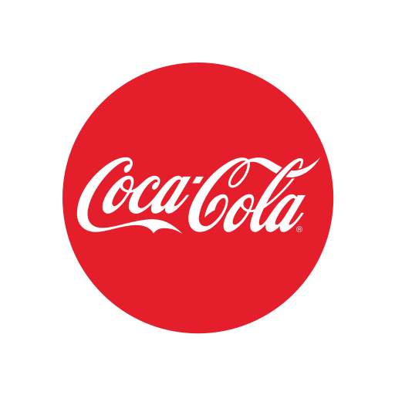

**3. Coca-Cola:**

* **COMPANY PROFILE:**
* 2019 revenue: $37 billion
* Number of employees: 86,000
* Headquarters: Atlanta, Georgia

The Coca-Cola Company is an American multinational corporation , best known as the producer of Coca-Cola. The drink industry company also manufactures, sells, and markets other non-alcoholic beverage concentrates and syrups, and alcoholic beverages. The Coca-Cola Company is a total beverage company with products sold in more than 200 countries and territories. Our company's purpose is to refresh the world and make a difference. Our portfolio of brands includes Coca-Cola, Sprite, Fanta and other sparkling soft drinks.

* **CONTRIBUTION TOWARDS GREEN SUPPLY CHAIN:**

The Coca-cola company consistently receives recognition for their efforts to combat and adapt to climate change and for their initiatives to develop a sustainable beverage industry. Recent accomplishments include achieving the company’s water replenishment goal, which was to return 100% of the water that they use annually, as well as reformulating 1,000 beverage brands since 2017; resulting in the removal of 350,000 tons of added sugar each year. The company has also reduced their carbon emission by 24% against a 2010 baseline and now sources more than 50% of their priority ingredients according to sustainable sourcing standards. One area of critical focus for Coca-cola is to make their packaging part of the developing circular economy. Currently, nearly 90% of the company’s packaging is recyclable and 20% is made from recycled materials.

**Sustainability resume:**

* AAA rating from MSCI ESG Ratings, the highest possible score achieve by only 5% of respondents
* Member of both the DJSI Europe and DJSI World list of sustainability leaders
* CDP Climate Change and Water A list member. Member of the CDP Supply Chain group.
* The Coca-Cola company has set a greenhouse gas emissions reduction target to reduce absolute scope 1, 2, and 3 GHG emissions 25% by 2030 from a 2015 base-year.
* One of 50 companies recognized at the 2019 SEAL Awards.

**Hence, these were the companies having green supply chain initiatives. These companies work to reduce waste, emissions, and other negative environmental impacts.**